Artificial Intelligence  
基于深度学习的机器视觉：垃圾分类

刘皓  
3160104994  
浙江大学计算机科学与技术学院

# 题目介绍

目前垃圾分类已经在许多城市开展起来。这看似微不足道的“小事”，实则关系到13亿多人生活环境的改善，理应通过人工智能技术来大力提倡社会风气养成。本次实验提供六个类别的垃圾识别分类数据集，分别是glass、cardboard、metal、paper、plastic、trash。本次实验是基于卷积神经网络模型来完成六个类别垃圾分类。

# 任务要求

每位同学单独完成；建立神经网络模型，并尽可能将其参数调优到最佳状态；绘制深度学习模型图、绘制并分析学习曲线等；分析模型并试着调试不同学习率等超参数对模型的结果影响 ；使用Python语言。

# 实验方法

卷积神经网络 （Convolutional Neural Network, CNN）是一种结构类似于人类或动物的 视觉系统 的人工神经网络，包含一个或多个卷积层（Convolutional Layer）、池化层（Pooling Layer）和全连接层（Fully-connected Layer）。

# 搭建过程

我先尝试了VGG，发现模型始终不收敛，测试的正确率极低，仅有20%。

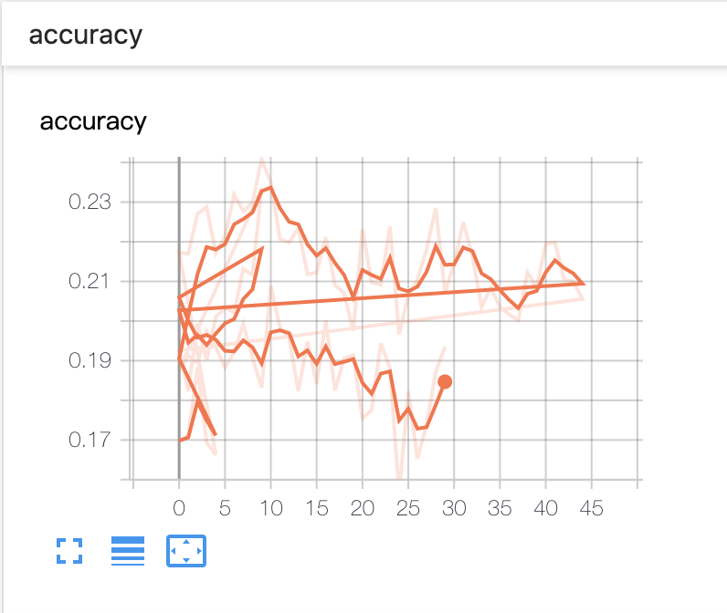

Figure 1不收敛的网络学习曲线

最终的网络模型是在ResNet v2的基础上修改而来的，因为原先的ResNet v2层数过多，且前面几层的尺寸过大，跑在GPU上显存会溢出。于是我在此基础上加入了几个池化层，在训练中出现了过拟合的现象，我又调整了正则项。最终的效果能达到80%的正确率。网络模型图如下所示。



# 训练过程

由于临近ddl，momodel网站的使用量大大增加，我每次对模型进行修改都要浪费大量时间等待，而我始终找不到窍门，需要大量的尝试，于是我从淘宝租用了GPU，改进网络的速度也大大加快了。

我将图像缩放到-1.0~1.0的范围，然后放入网络中训练和验证，过程如图。同时还使用了在训练过程中随时保存准确率最高的模型和随着epoch增加动态调整learning rate方法，最终的网络在数据集上训练了200个epoch，在1080ti上跑了五六个小时，学习曲线在下面的图中展示。

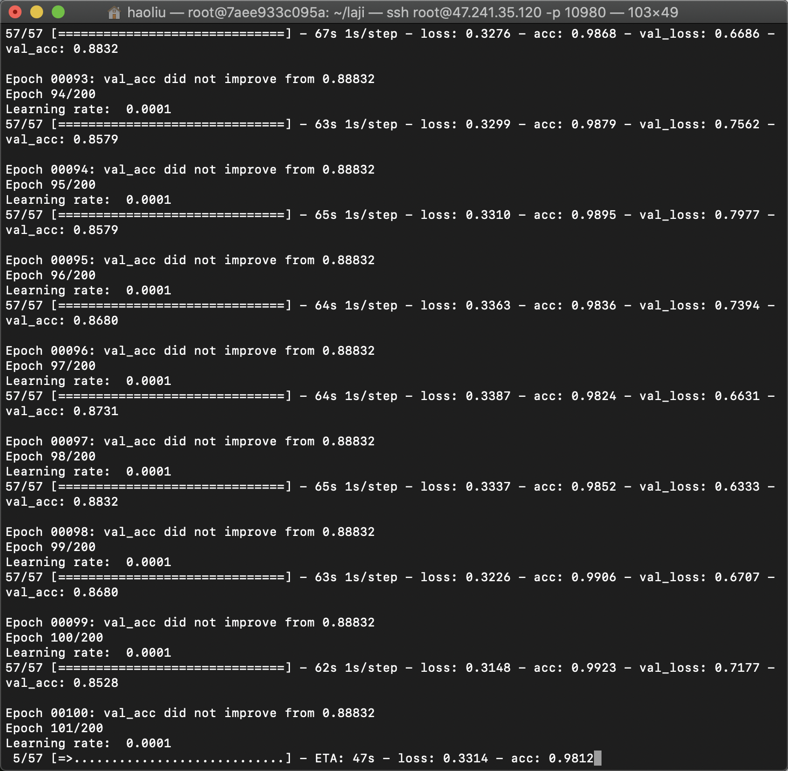

Figure 云GPU训练

**def** lr_schedule(epoch):  
 *"""学习率调度  
  
 学习率将在 80, 120, 160, 180 轮后依次下降。  
 他作为训练期间回调的一部分，在每个时期自动调用。  
  
 # 参数  
 epoch (int): 轮次  
  
 # 返回  
 lr (float32): 学习率  
 """* lr = 1e-3  
 **if** epoch > 180:  
 lr *= 0.5e-3  
 **elif** epoch > 160:  
 lr *= 1e-3  
 **elif** epoch > 120:  
 lr *= 1e-2  
 **elif** epoch > 80:  
 lr *= 1e-1  
 print(**'Learning rate: '**, lr)  
 **return** lr

训练过程中随时保存模型

checkpoint = ModelCheckpoint(filepath=**"./results/weights_{epoch:03d}-{val_acc:.4f}.h5"**,  
 monitor=**'val_acc'**,  
 verbose=1,  
 save_best_only=**True**)  
  
lr_scheduler = LearningRateScheduler(lr_schedule)  
  
lr_reducer = ReduceLROnPlateau(factor=np.sqrt(0.1),  
 cooldown=0,  
 patience=5,  
 min_lr=0.5e-6)  
  
tensorboard = TensorBoard(log_dir)  
  
callbacks = [checkpoint, lr_reducer, lr_scheduler, tensorboard]  
  
*# 训练模型, fit_generator函数:https://keras.io/models/model/#fit_generator  
# 利用Python的生成器，逐个生成数据的batch并进行训练。  
# callbacks: 实例列表。在训练时调用的一系列回调。详见 https://keras.io/callbacks/。*d = model.fit_generator(  
 *# 一个生成器或 Sequence 对象的实例* generator=train_generator,  
 *# epochs: 整数，数据的迭代总轮数。* epochs=epochs,  
 *# 一个epoch包含的步数,通常应该等于你的数据集的样本数量除以批量大小。* steps_per_epoch=1845 // batch_size,  
 *# 验证集* validation_data=validation_generator,  
 *# 在验证集上,一个epoch包含的步数,通常应该等于你的数据集的样本数量除以批量大小。* validation_steps=230 // batch_size,  
 callbacks=callbacks)

绘制出来的学习曲线如图，可以看到表现很优异，val_acc后期稳定在90%。

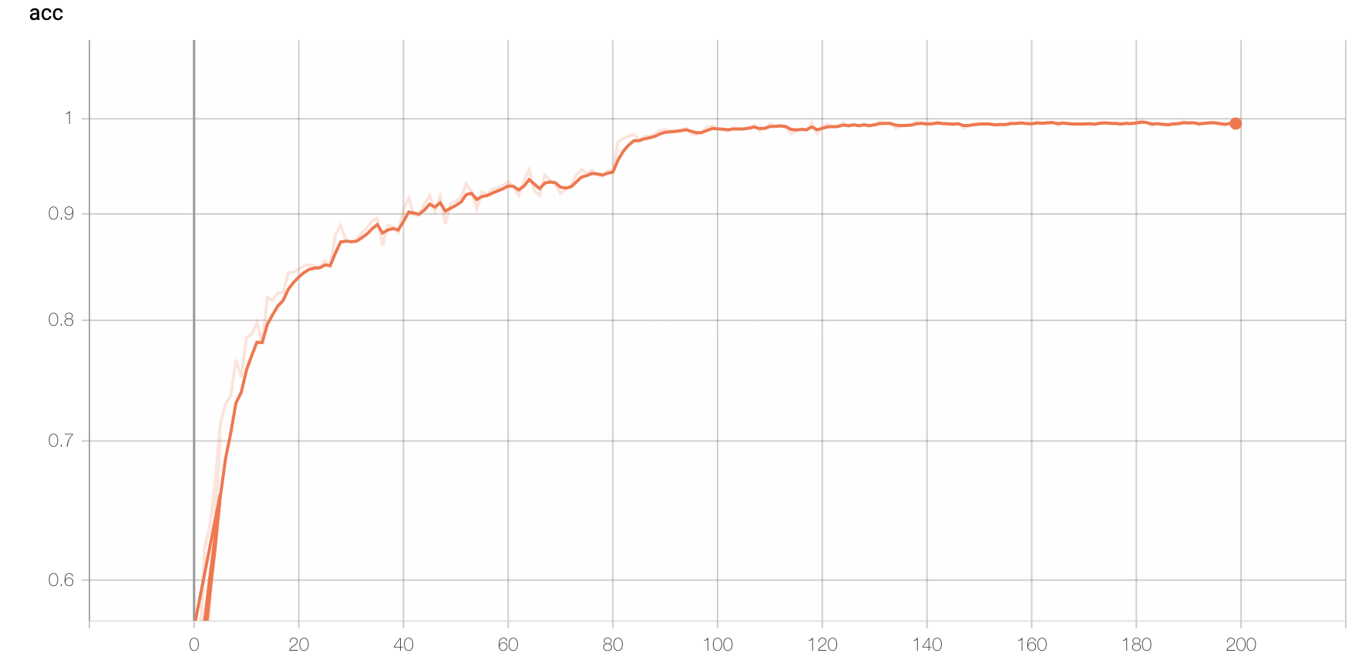

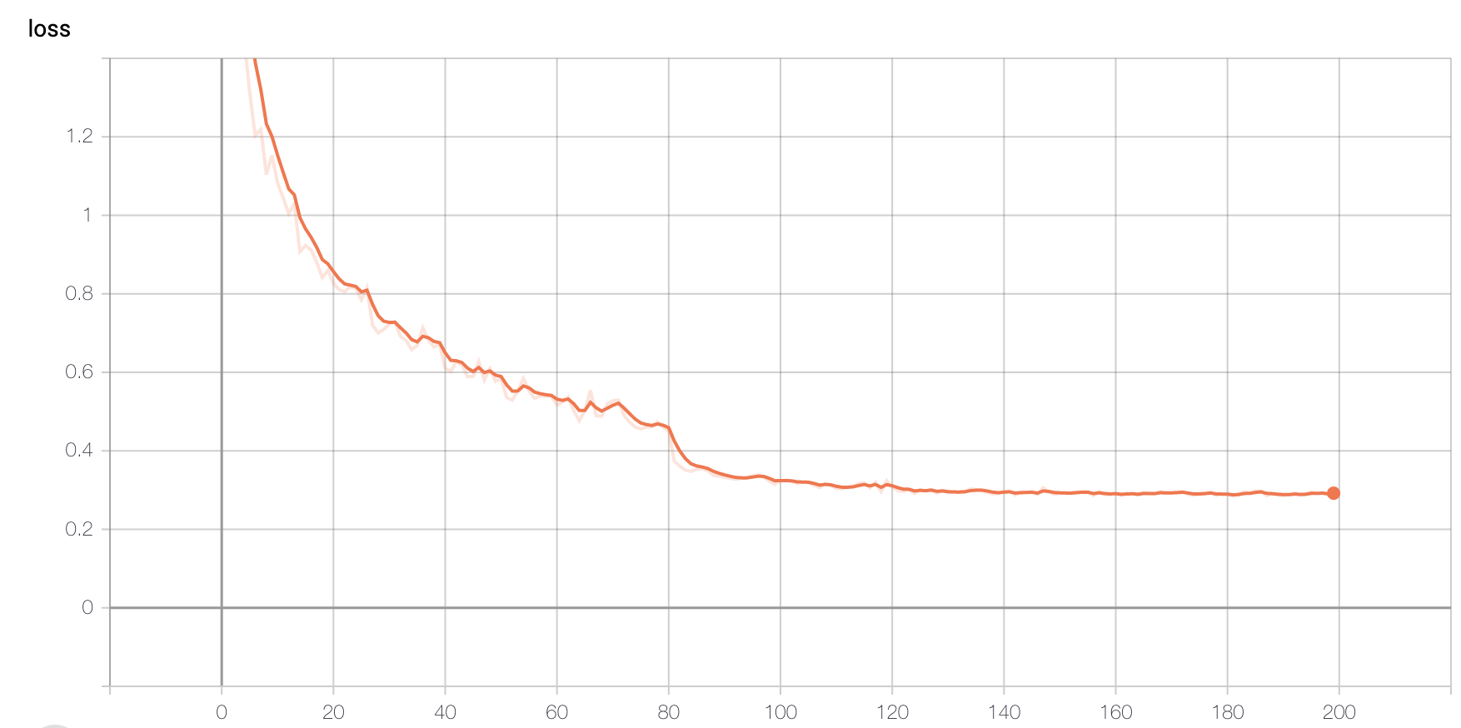

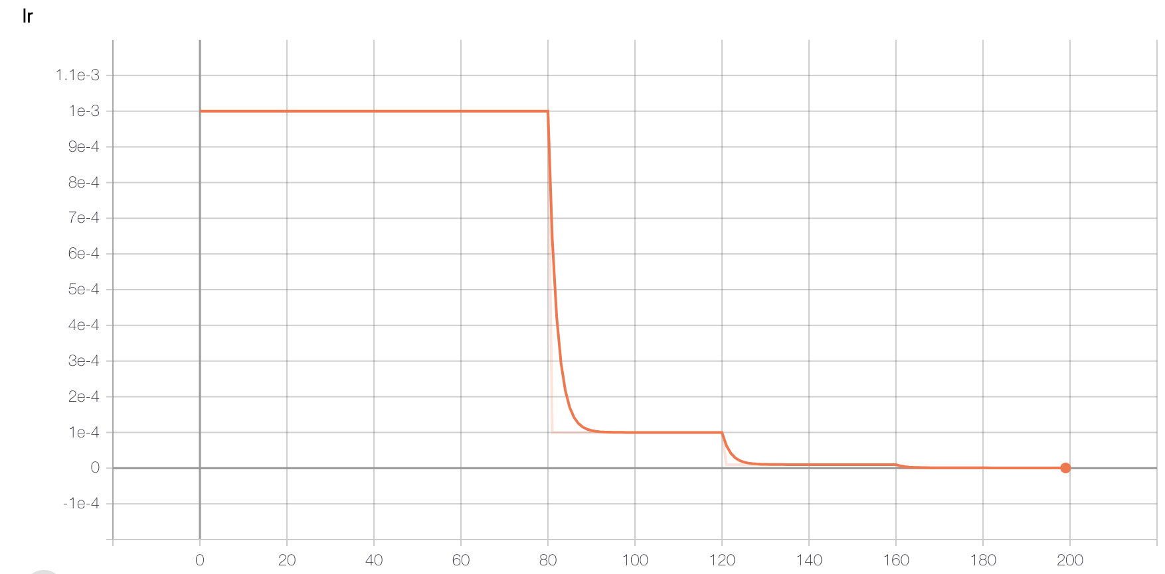

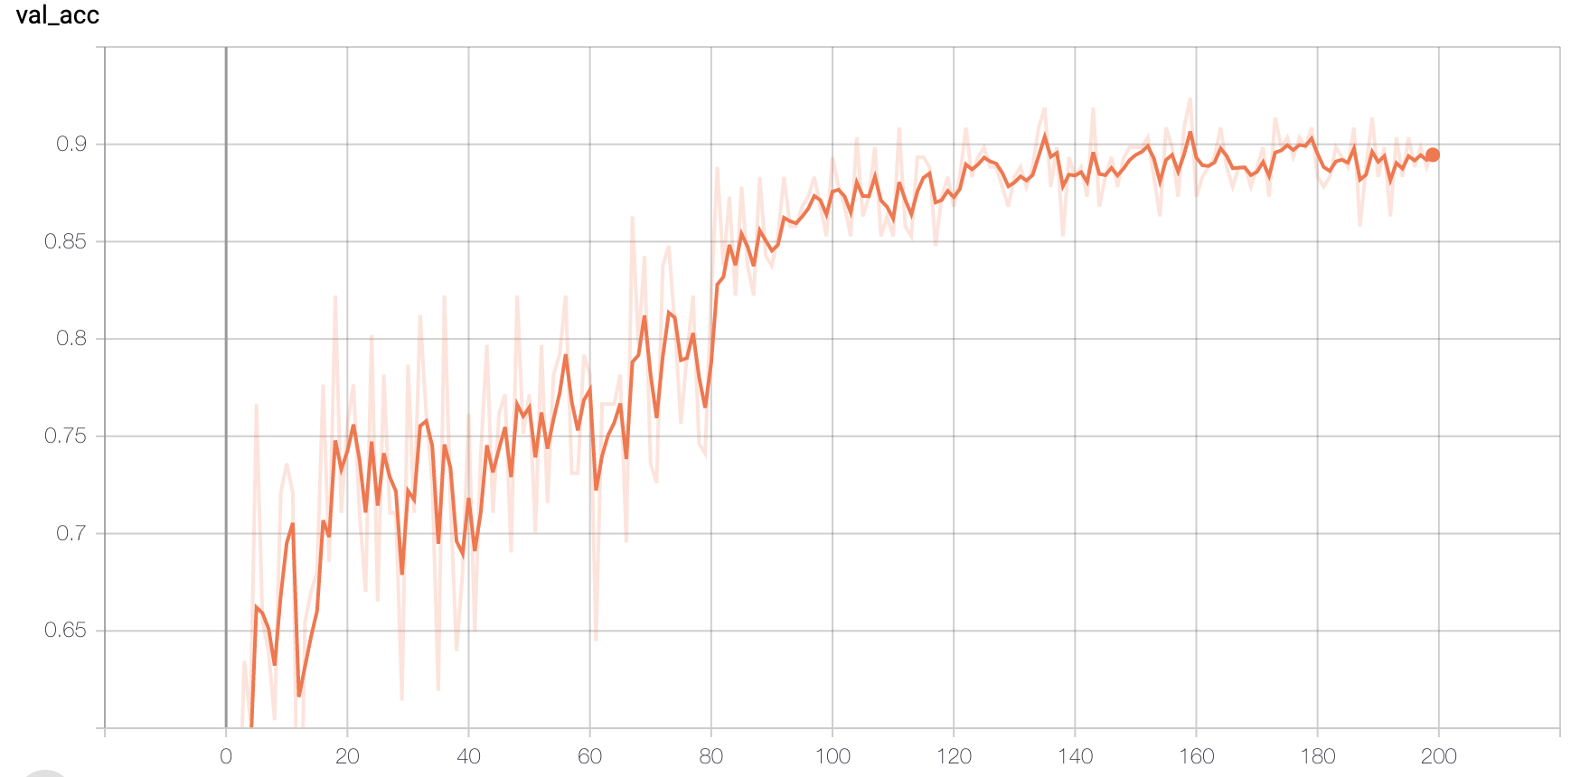

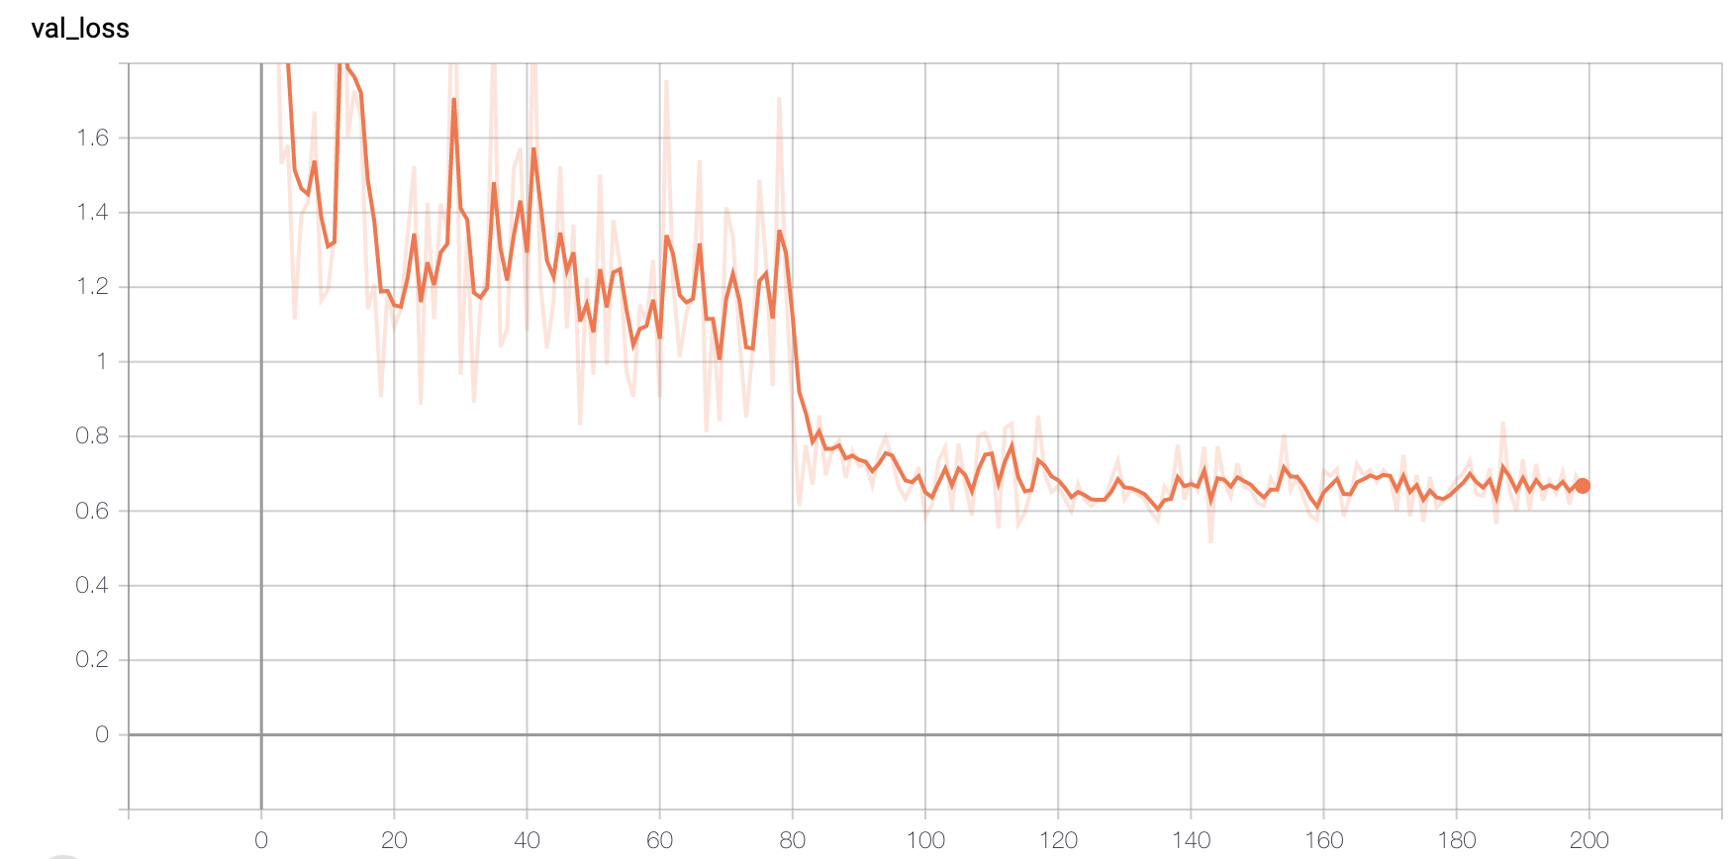

Figure 3学习曲线

# 结果展示

训练出来的模型在测试集上表现优异，达到了90.23%的正确率。

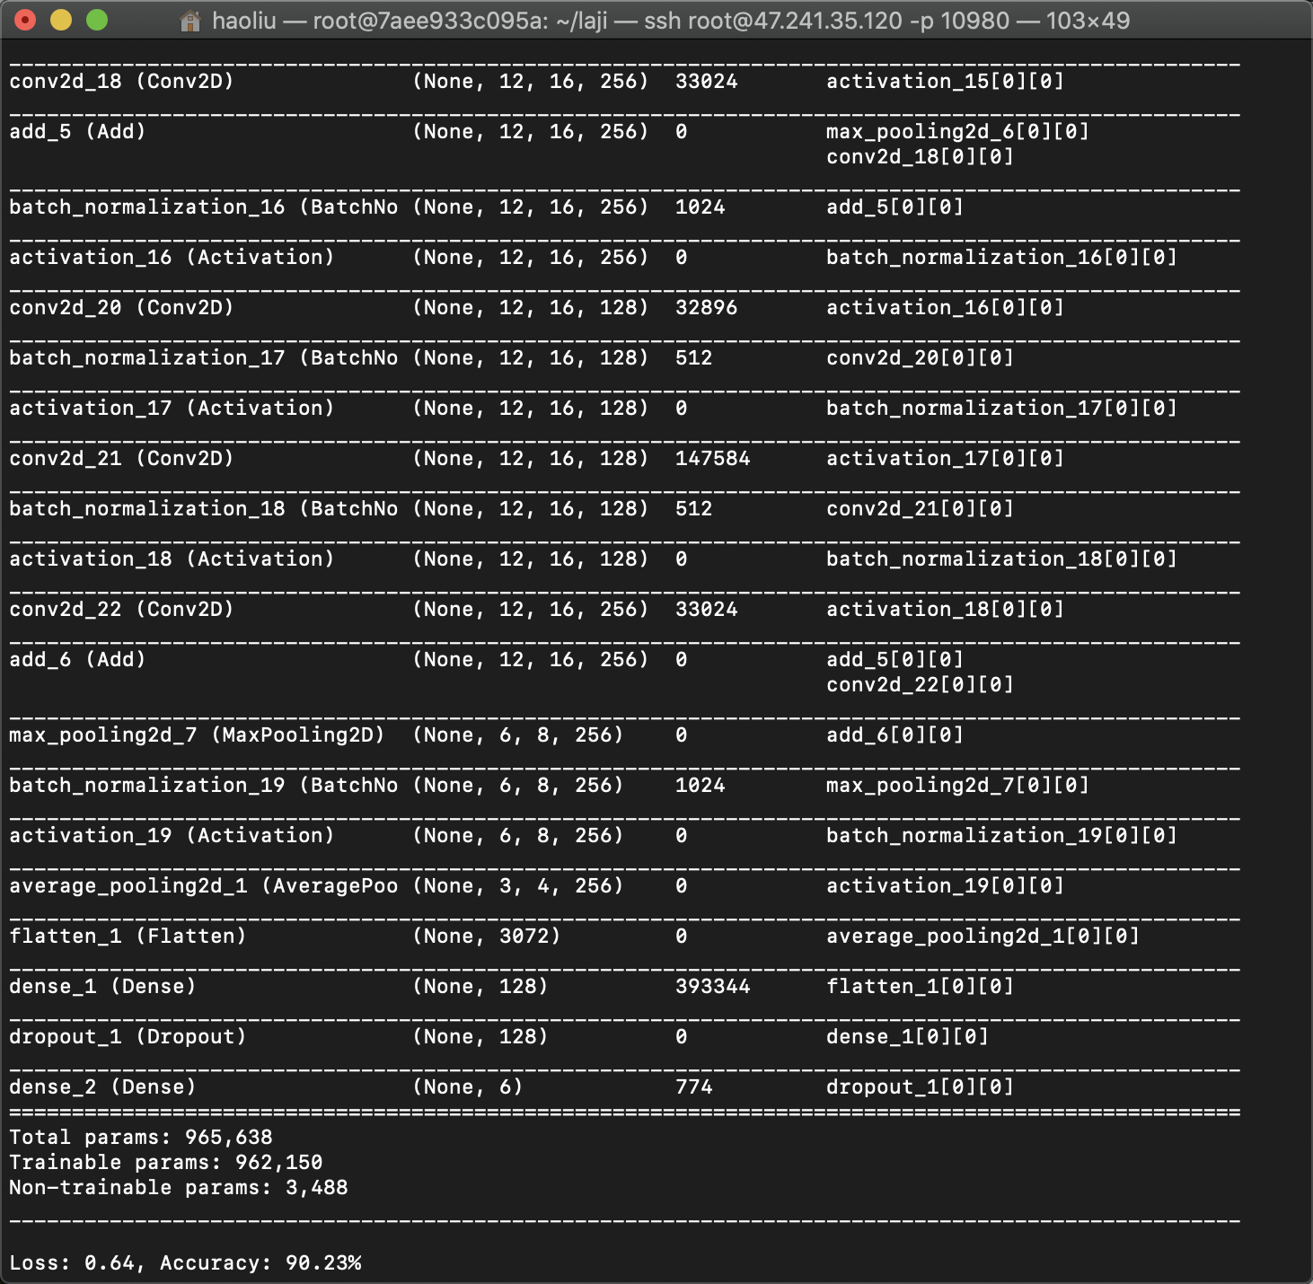

Figure 4 结果

通过了系统测试，模型将10张图片中的9张正确分类。

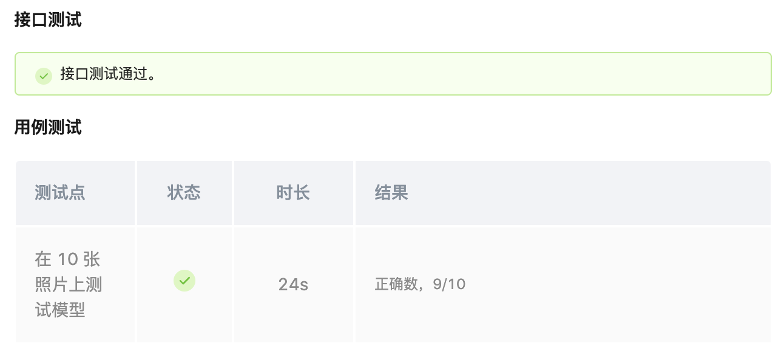

Figure 5 测试结果

# 总结与反思

从零开始，搭建一个神经网络，然后训练模型，测试，调整再测试……总的来说这个过程真的很有收获。虽然只是调用Keras，但通过实验感觉更深切地理解到了计算机视觉的原理。想想真的很奇妙，竟然能有人想出这么神奇的方式（神经网络）来模拟人类的视觉，而且竟然效果不错，计算机科学真是有趣。

在这个过程中我浪费了很多时间，有急得挠头的时候，比如排队等GPU，debug（predict的时候预处理没有和测试集完全一致真得困扰了我好久...），还有在各种框架和网络结构之间纠结的时候。

但同时我也收获了不少知识，多种框架的用法和异同，图像预处理，远程训练等等，最重要我对很多从前模模糊糊的概念心里有了底，比如训练集和验证集，神经网络的层是怎么回事等等，这门课真的很有意义。

# 参考资料

<https://keras.io/zh/>

<https://keras-zh.readthedocs.io/examples/cifar10_resnet/>

<https://tf.wiki/zh_hans/>

<http://pytorch123.com/>

<https://momodel.cn/docs/#/zh-cn/利用TensorBoard可视化评估模型?id=_2-撰写模型代码>

# 网络summary

__________________________________________________________________________________________________

Layer (type) Output Shape Param # Connected to

==================================================================================================

input_1 (InputLayer) (None, 384, 512, 3) 0

__________________________________________________________________________________________________

conv2d_1 (Conv2D) (None, 384, 512, 16) 448 input_1[0][0]

__________________________________________________________________________________________________

batch_normalization_1 (BatchNor (None, 384, 512, 16) 64 conv2d_1[0][0]

__________________________________________________________________________________________________

activation_1 (Activation) (None, 384, 512, 16) 0 batch_normalization_1[0][0]

__________________________________________________________________________________________________

conv2d_2 (Conv2D) (None, 384, 512, 16) 272 activation_1[0][0]

__________________________________________________________________________________________________

max_pooling2d_1 (MaxPooling2D) (None, 192, 256, 16) 0 conv2d_2[0][0]

__________________________________________________________________________________________________

batch_normalization_2 (BatchNor (None, 192, 256, 16) 64 max_pooling2d_1[0][0]

__________________________________________________________________________________________________

activation_2 (Activation) (None, 192, 256, 16) 0 batch_normalization_2[0][0]

__________________________________________________________________________________________________

conv2d_3 (Conv2D) (None, 192, 256, 16) 2320 activation_2[0][0]

__________________________________________________________________________________________________

batch_normalization_3 (BatchNor (None, 192, 256, 16) 64 conv2d_3[0][0]

__________________________________________________________________________________________________

conv2d_5 (Conv2D) (None, 384, 512, 64) 1088 activation_1[0][0]

__________________________________________________________________________________________________

activation_3 (Activation) (None, 192, 256, 16) 0 batch_normalization_3[0][0]

__________________________________________________________________________________________________

max_pooling2d_2 (MaxPooling2D) (None, 192, 256, 64) 0 conv2d_5[0][0]

__________________________________________________________________________________________________

conv2d_4 (Conv2D) (None, 192, 256, 64) 1088 activation_3[0][0]

__________________________________________________________________________________________________

add_1 (Add) (None, 192, 256, 64) 0 max_pooling2d_2[0][0]

conv2d_4[0][0]

__________________________________________________________________________________________________

batch_normalization_4 (BatchNor (None, 192, 256, 64) 256 add_1[0][0]

__________________________________________________________________________________________________

activation_4 (Activation) (None, 192, 256, 64) 0 batch_normalization_4[0][0]

__________________________________________________________________________________________________

conv2d_6 (Conv2D) (None, 192, 256, 16) 1040 activation_4[0][0]

__________________________________________________________________________________________________

batch_normalization_5 (BatchNor (None, 192, 256, 16) 64 conv2d_6[0][0]

__________________________________________________________________________________________________

activation_5 (Activation) (None, 192, 256, 16) 0 batch_normalization_5[0][0]

__________________________________________________________________________________________________

conv2d_7 (Conv2D) (None, 192, 256, 16) 2320 activation_5[0][0]

__________________________________________________________________________________________________

batch_normalization_6 (BatchNor (None, 192, 256, 16) 64 conv2d_7[0][0]

__________________________________________________________________________________________________

activation_6 (Activation) (None, 192, 256, 16) 0 batch_normalization_6[0][0]

__________________________________________________________________________________________________

conv2d_8 (Conv2D) (None, 192, 256, 64) 1088 activation_6[0][0]

__________________________________________________________________________________________________

add_2 (Add) (None, 192, 256, 64) 0 add_1[0][0]

conv2d_8[0][0]

__________________________________________________________________________________________________

batch_normalization_7 (BatchNor (None, 192, 256, 64) 256 add_2[0][0]

__________________________________________________________________________________________________

activation_7 (Activation) (None, 192, 256, 64) 0 batch_normalization_7[0][0]

__________________________________________________________________________________________________

conv2d_9 (Conv2D) (None, 96, 128, 64) 4160 activation_7[0][0]

__________________________________________________________________________________________________

max_pooling2d_3 (MaxPooling2D) (None, 48, 64, 64) 0 conv2d_9[0][0]

__________________________________________________________________________________________________

batch_normalization_8 (BatchNor (None, 48, 64, 64) 256 max_pooling2d_3[0][0]

__________________________________________________________________________________________________

activation_8 (Activation) (None, 48, 64, 64) 0 batch_normalization_8[0][0]

__________________________________________________________________________________________________

conv2d_10 (Conv2D) (None, 48, 64, 64) 36928 activation_8[0][0]

__________________________________________________________________________________________________

batch_normalization_9 (BatchNor (None, 48, 64, 64) 256 conv2d_10[0][0]

__________________________________________________________________________________________________

conv2d_12 (Conv2D) (None, 96, 128, 128) 8320 add_2[0][0]

__________________________________________________________________________________________________

activation_9 (Activation) (None, 48, 64, 64) 0 batch_normalization_9[0][0]

__________________________________________________________________________________________________

max_pooling2d_4 (MaxPooling2D) (None, 48, 64, 128) 0 conv2d_12[0][0]

__________________________________________________________________________________________________

conv2d_11 (Conv2D) (None, 48, 64, 128) 8320 activation_9[0][0]

__________________________________________________________________________________________________

add_3 (Add) (None, 48, 64, 128) 0 max_pooling2d_4[0][0]

conv2d_11[0][0]

__________________________________________________________________________________________________

batch_normalization_10 (BatchNo (None, 48, 64, 128) 512 add_3[0][0]

__________________________________________________________________________________________________

activation_10 (Activation) (None, 48, 64, 128) 0 batch_normalization_10[0][0]

__________________________________________________________________________________________________

conv2d_13 (Conv2D) (None, 48, 64, 64) 8256 activation_10[0][0]

__________________________________________________________________________________________________

batch_normalization_11 (BatchNo (None, 48, 64, 64) 256 conv2d_13[0][0]

__________________________________________________________________________________________________

activation_11 (Activation) (None, 48, 64, 64) 0 batch_normalization_11[0][0]

__________________________________________________________________________________________________

conv2d_14 (Conv2D) (None, 48, 64, 64) 36928 activation_11[0][0]

__________________________________________________________________________________________________

batch_normalization_12 (BatchNo (None, 48, 64, 64) 256 conv2d_14[0][0]

__________________________________________________________________________________________________

activation_12 (Activation) (None, 48, 64, 64) 0 batch_normalization_12[0][0]

__________________________________________________________________________________________________

conv2d_15 (Conv2D) (None, 48, 64, 128) 8320 activation_12[0][0]

__________________________________________________________________________________________________

add_4 (Add) (None, 48, 64, 128) 0 add_3[0][0]

conv2d_15[0][0]

__________________________________________________________________________________________________

batch_normalization_13 (BatchNo (None, 48, 64, 128) 512 add_4[0][0]

__________________________________________________________________________________________________

activation_13 (Activation) (None, 48, 64, 128) 0 batch_normalization_13[0][0]

__________________________________________________________________________________________________

conv2d_16 (Conv2D) (None, 24, 32, 128) 16512 activation_13[0][0]

__________________________________________________________________________________________________

max_pooling2d_5 (MaxPooling2D) (None, 12, 16, 128) 0 conv2d_16[0][0]

__________________________________________________________________________________________________

batch_normalization_14 (BatchNo (None, 12, 16, 128) 512 max_pooling2d_5[0][0]

__________________________________________________________________________________________________

activation_14 (Activation) (None, 12, 16, 128) 0 batch_normalization_14[0][0]

__________________________________________________________________________________________________

conv2d_17 (Conv2D) (None, 12, 16, 128) 147584 activation_14[0][0]

__________________________________________________________________________________________________

batch_normalization_15 (BatchNo (None, 12, 16, 128) 512 conv2d_17[0][0]

__________________________________________________________________________________________________

conv2d_19 (Conv2D) (None, 24, 32, 256) 33024 add_4[0][0]

__________________________________________________________________________________________________

activation_15 (Activation) (None, 12, 16, 128) 0 batch_normalization_15[0][0]

__________________________________________________________________________________________________

max_pooling2d_6 (MaxPooling2D) (None, 12, 16, 256) 0 conv2d_19[0][0]

__________________________________________________________________________________________________

conv2d_18 (Conv2D) (None, 12, 16, 256) 33024 activation_15[0][0]

__________________________________________________________________________________________________

add_5 (Add) (None, 12, 16, 256) 0 max_pooling2d_6[0][0]

conv2d_18[0][0]

__________________________________________________________________________________________________

batch_normalization_16 (BatchNo (None, 12, 16, 256) 1024 add_5[0][0]

__________________________________________________________________________________________________

activation_16 (Activation) (None, 12, 16, 256) 0 batch_normalization_16[0][0]

__________________________________________________________________________________________________

conv2d_20 (Conv2D) (None, 12, 16, 128) 32896 activation_16[0][0]

__________________________________________________________________________________________________

batch_normalization_17 (BatchNo (None, 12, 16, 128) 512 conv2d_20[0][0]

__________________________________________________________________________________________________

activation_17 (Activation) (None, 12, 16, 128) 0 batch_normalization_17[0][0]

__________________________________________________________________________________________________

conv2d_21 (Conv2D) (None, 12, 16, 128) 147584 activation_17[0][0]

__________________________________________________________________________________________________

batch_normalization_18 (BatchNo (None, 12, 16, 128) 512 conv2d_21[0][0]

__________________________________________________________________________________________________

activation_18 (Activation) (None, 12, 16, 128) 0 batch_normalization_18[0][0]

__________________________________________________________________________________________________

conv2d_22 (Conv2D) (None, 12, 16, 256) 33024 activation_18[0][0]

__________________________________________________________________________________________________

add_6 (Add) (None, 12, 16, 256) 0 add_5[0][0]

conv2d_22[0][0]

__________________________________________________________________________________________________

max_pooling2d_7 (MaxPooling2D) (None, 6, 8, 256) 0 add_6[0][0]

__________________________________________________________________________________________________

batch_normalization_19 (BatchNo (None, 6, 8, 256) 1024 max_pooling2d_7[0][0]

__________________________________________________________________________________________________

activation_19 (Activation) (None, 6, 8, 256) 0 batch_normalization_19[0][0]

__________________________________________________________________________________________________

average_pooling2d_1 (AveragePoo (None, 3, 4, 256) 0 activation_19[0][0]

__________________________________________________________________________________________________

flatten_1 (Flatten) (None, 3072) 0 average_pooling2d_1[0][0]

__________________________________________________________________________________________________

dense_1 (Dense) (None, 128) 393344 flatten_1[0][0]

__________________________________________________________________________________________________

dropout_1 (Dropout) (None, 128) 0 dense_1[0][0]

__________________________________________________________________________________________________

dense_2 (Dense) (None, 6) 774 dropout_1[0][0]

==================================================================================================

Total params: 965,638

Trainable params: 962,150

Non-trainable params: 3,488